1.1 INTRODUCTION

1.1.1 Purpose
This document establishes the requirements for the software component Seat Belt Reminder to be implemented as part of the project ACU AEP.

1.1.2 Scope
The requirements described here are valid for the ACU AEP.

1.1.3 Reference Documents

1.2 DEVELOPMENT CONTEXT

1.2.1 Component Borderlines
The Seat Belt Reminder is responsible for:
- Switching on/off the driver and passenger reminder telltales
- It commands the DIC to display buckled status
- Command the chime

1.2.2 Development and Design Constraints
The runtime of Seat Belt Reminder functions basically does not need to be restricted, but this runtime has to be balanced against the runtime of other tasks with regard to the overall available runtime.

1.2.3 Concept
The Seat Belt reminder is realized dividing its functionality in submodules:
- Driver Reminder
- Passenger Reminder
- DIC (Driver information center)
- Chime manager
- Seat Belt Reminder handler

1.3 INTERFACES

1.3.1 Inputs Processed by the Component
The Seat Belt Reminder module must check the following data:
- Operation Mode
- Vehicle Speed, Distance traveled and Engine status, available as CAN messages.
- Driver Front Door switch status, available as CAN messages
- Chime active status, available as CAN message.
- Buckle switch status and occupancy status for all vehicle passengers read from Occupancy Handling module.

1.3.2 Outputs Generated by the Component
- CAN messages to control the chime
- CAN messages to control the driver reminder and passenger reminder telltales

1.4 FUNCTIONAL SPECIFICATION

1.4.1 Requirements
The Subsystem components are to perform the following functions:
The ACU shall command Driver Seatbelt Indicator and a chime or other annunciation device such as a DIC (Driver Information Center) which display a text message.
The ACU shall illuminate the Passenger Seatbelt Indicator and Suppression Indicators.

1.4.1.2 Telltale Interfaces (ON_TT, OFF_TT)
The front passenger airbag ON, airbag OFF, and seatbelt reminder telltale interface requirements for the ACU are:
Interface Name(s) ON_TT, OFF_TT
Interface Type Output - High Side Driver

Duty Cycle Range ON_TT, OFF_TT

0 % (driver off) to 100 % (driver on)

Table 11 – ACU – Telltale Interface Characteristics

1.4.1.3 Application Software Requirements

1.4.1.3.1 Front Passenger Seat Occupancy Sensing
The SBRS provides means to detect the presence of occupant on the front passenger seat which is used in passenger seatbelt reminder.

1.4.1.3.2 ACU Operating Mode Handler

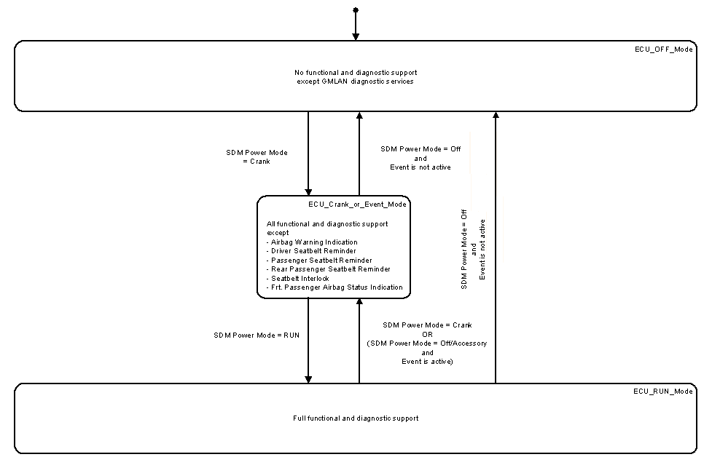
Figure 22 - ACU Operating Mode Handler

1.4.2 Behavior Description
See following chapters

1.4.3 Operation Modes
See following chapters

1.4.4 Initialization
See following chapters

1.4.5 Self-diagnosis Aspects
See following chapters

1.4.6 Configuration
See following chapters

1.4.7 Fault Handling and Reaction
See following chapters

2 Seat Belt Reminder - Driver

2.1 INTRODUCTION

2.1.1 Purpose
This document establishes the requirements for the software component Seat Belt Reminder - Driver to be implemented as part of the project ACU AEP

2.1.2 Scope
The requirements described here are valid for the ACU.

2.2 DEVELOPMENT CONTEXT

2.2.1 Component Borderlines
The Seat Belt Reminder - Driver is responsible for switching on/off the driver reminder telltale and commands the chime with the appropriate time for driver reminder

2.2.2 Development and Design Constraints
The runtime of Seat Belt Reminder - Driver functions basically does not need to be restricted, but this runtime has to be balanced against the runtime of other tasks with regard to the overall available runtime.

2.2.3 Concept
The Seat Belt Reminder - Driver is realized as a state machine when driver is unbuckled. When driver is buckled, the chime is commanded OFF and Driver Reminder Telltale is OFF. When driver is unbuckled, there are 3 reminder states controlled with many configurable parameters that controls chime duration, telltale, wait times, and state transition conditions.

2.3 INTERFACES

2.3.1 Inputs Processed by the Component
The Seat Belt Reminder - Driver shall process:
- Vehicle Speed, Distance traveled and Engine active status from Seat Belt Reminder Handler module
- Driver buckle status from Occupancy Handling component

2.3.2 Outputs Generated by the Component
- CAN message to switch on/off driver reminder telltale.
- Request chime sound through Chime manager interface.
- CAN message to command DIC, through DIC manager interface (if configured).

2.4 FUNCTIONAL SPECIFICATION

2.4.1 Driver Seatbelt Reminder

Prompts to encourage driver's seatbelt use include an audible chime, instrument panel cluster telltale and as a configurable option a DIC with integrated chime. The driver seatbelt reminder is available as a configurable option as regional requirements are different.

The requirements for driver seatbelt reminder are specified to meet North America (MVSS208) and Europe (EuroNCAP) requirements using configurable options.
In telltale mode, there are three options which control the visual moding of the driver seat belt reminder telltale.

1) Enhanced Reminder operation comprised of a multiple reminder sequence with short audible chime (8 seconds) and dependent on vehicle speed for indicating unfastened driver seat belt condition (intended to meet FMVSS208)

2) Euro Reminder comprised of a multiple reminder sequence with long audible chime (90 seconds) and dependent on vehicle speed or distance traveled or driver door status with unfastened seat belt condition for indicating unfastened driver seat belt condition (designed to meet EuroNCAP requirements).

In Enhanced DIC mode, a DIC text message (“Buckle Seatbelt”) is displayed depending on vehicle speed in addition to the use of telltale for indicating unfastened driver seatbelt condition.

2.4.1.1 General
The ACU shall use driver seatbelt switch for detecting seatbelt fastened/unfastened status.
The ACU shall enable Driver Seatbelt Reminder moding when all of the following conditions are met:
1. ACU Power Mode is RUN and
2. ACU is configured to provide driver seatbelt reminder moding
The ACU shall disable Driver Seatbelt Reminder moding when any condition to enable driver seatbelt reminder moding is not met.
The ACU shall turn the chime “off”, the telltale “off”, and the DIC Indication “off” when driver seatbelt reminder moding is disabled.
The maximum operational latency requirement for this feature is 25.0 ± 0.1 ms unless otherwise specified in the individual requirements for this feature.
Once enabled, the ACU shall meet the requirements specified for driver seatbelt reminder moding depending on configurable options.
The ACU shall use the following CAN signal to provide status of the driver seatbelt to the rest of the vehicle.
1. Driver Seatbelt Status (Not Monitored/Unknown/Fastened/Unfastened)
2. Power up default for Distance Rolling Count Average Driven signal shall be 0. (Validity power up default per CAN database is Valid)
3. When Distance Rolling Count Average Driven is received with a value of zero all accumulated distance traveled with the driver unfastened condition shall be reset to zero (ACU does not receive the Distance Rolling Count Reset signal so this is a method of compensating for that).

2.4.1.2 Telltale Moding

a. The ACU shall use the following CAN message consisting of Indication On, Indication Duty Cycle, and Indication Period signals to control driver seatbelt reminder telltale moding.

2.4.1.2.1 Basic Reminder Operation
This section defines the basic reminder operation which provides single reminder sequence for unfastened driver seatbelt condition. It is designed to meet FMVSS208 requirements.
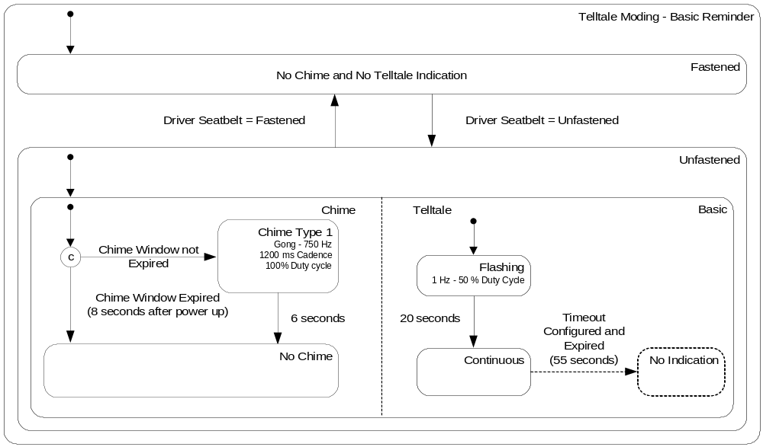
Figure 27 - Driver Seatbelt Reminder - Telltale Moding - Basic Reminder
a. If the configuration option for Telltale mode is Basic Reminder Operation then the ACU shall meet the requirements shown in Figure 27 with detailed requirements specified herein.
b. The ACU shall comply with FMVSS208 for chime and telltale activation periods.
c. If the driver seatbelt status is unfastened then
1. If the feature is enabled for less than 8.0 ± 0.1 seconds and the ACU is not in assembly plant mode then the ACU shall turn the chime “on” (Gong- 750 Hz, 1200 ms cadence with 100 % duty cycle) for 6.0 ± 0.1 seconds otherwise the ACU shall not turn the chime “on”.
2. The ACU shall flash the telltale “on” and “off” at a 1 Hz rate with 50% duty cycle for 20.0 ± 0.1 seconds and then
i. If the ACU is not configured with continuous reminder timeout option then the ACU shall turn the telltale continuous “on”.
ii. If the ACU is configured with continuous reminder timeout option then the ACU shall turn the telltale “on” for 55.0 ± 0.1 seconds and then turn the telltale “off”.

2.4.1.2.2 Enhanced Reminder Operation
This section defines the enhanced reminder operation which provides multiple reminder sequence for unfastened driver seatbelt condition. This operation uses vehicle speed to initiate enhanced reminder and provides additional audible/visual warnings for unfastened driver seatbelt condition
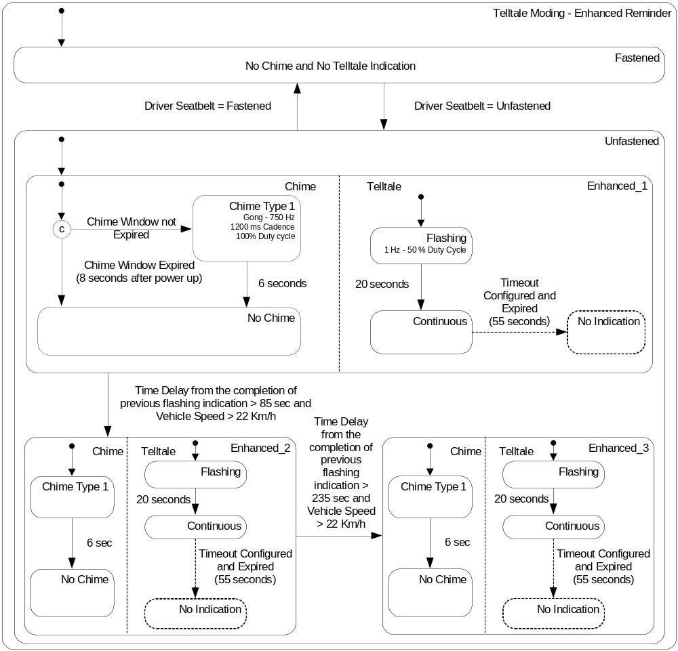
Figure 28 - Driver Seatbelt Reminder - Telltale Moding - Enhanced Reminder
a. If the configuration option for Telltale moding is Enhanced Reminder Operation then the ACU shall meet the requirements shown in Figure 28 with detailed requirements specified herein.
b. The ACU shall comply with FMVSS208 for chime and telltale activation periods.

c. If the driver seatbelt status is unfastened then
1. If the feature is enabled for less than 8.0 ± 0.1 seconds and the ACU is not in assembly plant mode then the ACU shall turn the chime “on” (Gong- 750 Hz, 1200 ms cadence with 100 % duty cycle) for 6.0 ± 0.1 seconds otherwise the ACU shall not turn the chime “on”.
2. The ACU shall flash the telltale “on” and “off” at a 1 Hz rate with 50% duty cycle for 20.0 ± 0.1 seconds and then
i. If the ACU is not configured with continuous reminder timeout option then the ACU shall turn the telltale continuous “on”.
ii. If the ACU is configured with continuous reminder timeout option then the ACU shall turn the telltale “on” for 55.0 ± 0.1 seconds and then turn the telltale “off”.
3. When 85.0 ± 0.1 seconds expires since the completion of the previous flashing indication and the Vehicle Speed exceeds 22 km/h then
i. If the ACU is not in assembly plant mode and the ACU is configured with Chime Usage for Extended Reminder then the ACU shall turn the chime “on” (Gong- 750 Hz, 1200 ms cadence with 100 % duty cycle) for 6.0 ± 0.1 seconds otherwise the ACU shall not turn the chime “on”.
ii. The ACU shall flash the telltale “on” and “off” at a 1 Hz rate with 50% duty cycle for 20.0 ± 0.1 seconds and then
a) If the ACU is not configured with continuous reminder timeout option then the ACU shall turn the telltale “on”.
b) If the ACU is configured with continuous reminder timeout option then the ACU shall turn the telltale “on” for 55.0 ± 0.1 seconds and then turn the telltale “off”.
4. When 235.0 ± 0.1 seconds expires since the completion of the previous flashing indication and the Vehicle Speed exceeds 22 km/h then
i. If the ACU is not in assembly plant mode and the ACU is configured with Chime Usage for Extended Reminder then the ACU shall turn the chime “on” (Gong- 750 Hz, 1200 ms cadence with 100 % duty cycle) for 6.0 ± 0.1 seconds otherwise the ACU shall not turn the chime “on”.
ii. The ACU shall flash the telltale “on” and “off” at a 1 Hz rate with 50% duty cycle for 20.0 ± 0.1 seconds and then
a) If the ACU is not configured with continuous reminder timeout option then the ACU shall turn the telltale “on”.
b) If the ACU is configured with continuous reminder timeout option then the ACU shall turn the telltale “on” for 55.0 ± 0.1 seconds and then turn the telltale “off”.

2.4.1.2.3 Euro Reminder Operation
This section defines the euro reminder operation which provides multiple reminder sequence for unfastened driver seatbelt condition. This operation uses engine run active, vehicle speed, distance traveled, and driver door status to initiate enhanced reminder and provides additional audible/visual warnings for unfastened driver seatbelt condition. It is designed to meet EuroNCAP requirements.
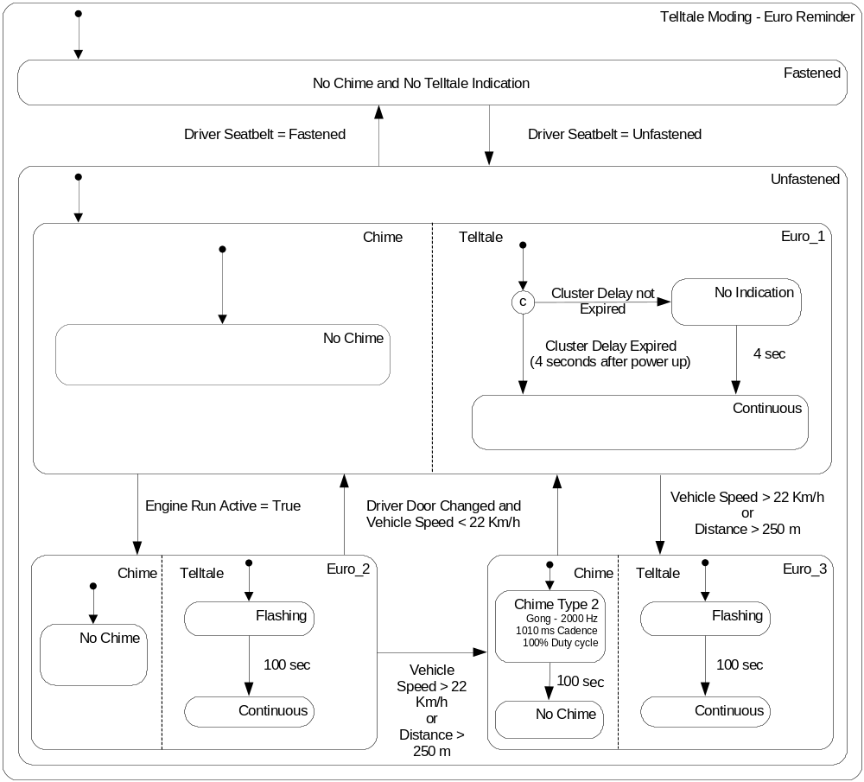
Figure 29 - Driver Seatbelt Reminder - Telltale Moding - Euro Reminder
a. If the configuration option for Telltale mode is Euro Reminder Operation then the ACU shall meet the requirements shown in Figure 29 with detailed requirements specified herein.
b. During the first 4.0 ± 0.1 seconds (calibrateable) of enabling this feature, the ACU shall not command telltale or chime.

c. If the Driver Seatbelt Switch Status is unfastened after the first 4.0 ± 0.1 seconds (calibrateable) of enabling this feature then
1. The distance traveled with the driver unfastened condition shall be initially set to zero.
2. The ACU shall turn the telltale continuous “on”.
3. When the Engine Run Active becomes true then
i. The ACU shall flash the telltale “on” and “off” at a 1 Hz rate with 50% duty cycle for 100.0 ± 0.1 seconds and then turn the telltale continuous “on”.
4. When the Vehicle Speed exceeds 22 km/h or distance traveled with the driver unfastened condition exceeds 250 m then
i. The ACU shall flash the telltale “on” and “off” at a 1 Hz rate with 50% duty cycle for 100.0 ± 0.1 seconds and then turn the telltale continuous “on”.
ii. If the ACU is configured with Chime Usage for Extended Reminder then the ACU shall turn the chime “on” (Gong- 2 KHz, 1010 ms cadence with 100 % duty cycle) for 100.0 ± 0.1 seconds otherwise the ACU shall not turn the chime “on”.
5. If the Driver Door Status changes and Vehicle Speed is less than 22 km/h then
i. The distance traveled with the driver unfastened condition shall be reset to zero.
ii. If the chime is active then the chime shall be turned “off”.
iii. The ACU shall turn the telltale continuous “on”.
iv. The ACU shall re-initiate the driver seatbelt unfastened reminder sequence depending on engine run active, vehicle speed and distance traveled conditions as specified above in c.

2.4.1.3 Enhanced DIC Moding
In an optional Enhanced DIC mode, a text message (“Buckle Seatbelt”) is displayed in addition to the use of telltale for unfastened driver seatbelt condition.
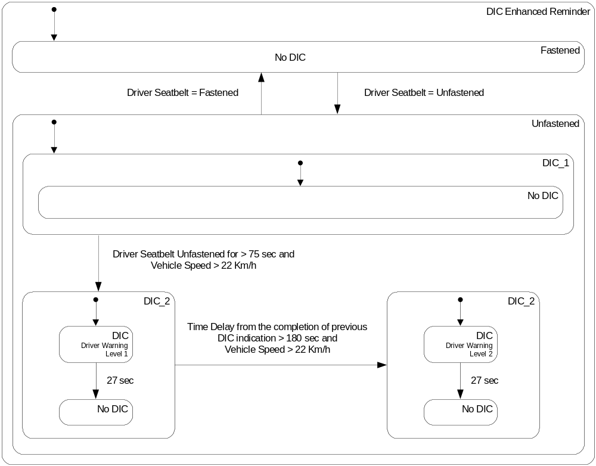
Figure 31 - Driver Seatbelt Reminder - Enhanced DIC Moding
a. The ACU shall allow Enhanced DIC Mode to be available as a configuration option.
b. The ACU shall use the Fasten Driver Seatbelt Auxiliary Indication Request from DIC manager, to control Enhanced DIC mode.

c. The ACU shall not activate Enhanced DIC Mode if the ACU is in the assembly plant mode.
d. If the ACU is configured for Enhanced DIC Mode and if the ACU is not in the assembly plant mode then the ACU shall meet the requirements shown in Figure 31 with detailed requirements specified herein.
e. If the driver seatbelt status changes to fastened then
1. The ACU shall turn the DIC Indication “off” if the DIC Indication is active.
f. When the driver remains unfastened for 75.0 ± 0.1 seconds and the Vehicle Speed exceeds 22 km/h then
1. The ACU shall turn the DIC Indication “on” for 27.0 ± 0.1 seconds and then turn the DIC Indication “off”.
g. When 180.0 ± 0.1 seconds expires since the completion of the previous DIC indication and the Vehicle Speed exceeds 22 km/h then
1. The ACU shall turn the DIC Indication “on” for 27.0 ± 0.1 seconds and then turn the DIC Indication “off”.

2.4.1.4 Deactivation of Driver Seatbelt Reminder Operation

a. The ACU shall allow a configuration option - Chime Usage for Extended Reminder, which will activate or deactivate the seatbelt reminder chime without affecting regulatory requirements for Enhanced Reminder and Euro Reminder operations to be modified using configuration values.

2.4.2 Behavior Description
Not applicable

2.4.3 Operation Modes
Not applicable

2.4.4 Initialization
The ACU shall use the driver seatbelt status as “fastened” as a default during power up.
The ACU shall use the telltale “off” and chime “off” as a default during power up.

2.4.5 Self-diagnosis Aspects
Not applicable

2.4.6 Configuration
The ACU shall allow Driver Seat belt Reminder feature to be available as a configurable option (K_SBR_DSBR_Enable).
The ACU shall meet the requirements specified for the Driver Seat belt Reminder using a single algorithm with a single set of configurable options (DID $4B) which can be modified to provide functionality specified for different reminder operations as described below. (The typical values for these configurable options are specified herein
1. Telltale Mode options which will cover functionality specified for Basic, Enhanced, and Euro Reminders
i. Number of reminder steps
ii. Use of delay for first reminder and threshold for initial delay timer
iii. Use of delay between reminder steps and thresholds for delay timers
iv. Use of vehicle speed and threshold for vehicle speed
v. Use of distance traveled and threshold for distance traveled
vi. Use of engine run active
vii. Use of driver door status
viii. Chime Moding options
a) Chime periods for different reminder steps
b) Chime allowed window for first reminder
c) Chime Characteristics
ix. Telltale Illumination rate and period
x. Solid and Flash Telltale mode periods for different reminder steps
xi. Use of continuous reminder timeout
xii. Chime usage for extended reminder
2. Use of Enhanced DIC Moding

2.4.7 Fault Handling and Reaction
Not applicable

3 Seat Belt Reminder - Passenger
ID : 393

3.1 INTRODUCTION

3.1.1 Purpose
This document establishes the requirements for the software component Seat Belt Reminder - Passenger to be implemented as part of the project ACU AEP

3.1.2 Scope
The requirements described here are valid for the ACU AEP If generic requirements are used, they are linked to the generic requirement specification.

3.2 DEVELOPMENT CONTEXT

3.2.1 Component Borderlines
The Seat Belt Reminder - Passenger is responsible for switching on/off the passenger reminder telltale and command the chime with the appropriate time for passenger reminder

3.2.2 Development and Design Constraints
The runtime of Seat Belt Reminder - Passenger functions basically does not need to be restricted, because these functions are executed within an OSEK task, but this runtime has to be balanced against the runtime of other tasks with regard to the overall available runtime.

3.2.3 Concept
The Seat Belt Reminder - Passenger is realized as a state machine when passenger is unbuckled. When passenger is buckled, the chime is commanded OFF and Passenger Reminder Telltale is OFF. When passenger is unbuckled, there are 3 reminder states controlled with many configurable parameters that controls chime duration, telltale, wait times, and state transition conditions.

3.3 INTERFACES

3.3.1 Inputs Processed by the Component
The Seat Belt Reminder - Passenger shall process:
- Vehicle Speed, Distance travelled and Engine active status from Seat Belt Reminder Handler module
- Passenger buckle status from Occupancy Handling component
- Passenger occupancy status from Occupancy Handling component

3.3.2 Outputs Generated by the Component
- CAN message to switch on/off passenger reminder telltale.
- Request chime sound through Chime manager interface.
- CAN message to command DIC, through DIC manager interface (if confiured).

3.4 FUNCTIONAL SPECIFICATION

3.4.1 Passenger Seatbelt Reminder
Prompts to encourage passenger's seatbelt use include an audible chime, telltale, and as a configurable option a DIC with integrated chime. The passenger seatbelt reminder is available as a configurable option. The requirements for passenger seatbelt reminder are specified to meet North America and Europe (EuroNCAP) requirements using configurable options.
In telltale moding, there are four different options which control the visual moding of the passenger seatbelt reminder telltale. In Basic Reminder operation, a single reminder sequence is provided for indicating unfastened passenger seatbelt condition. In Enhanced Reminder operation, multiple reminder sequence with short audible chime (8 seconds) is provided depending on vehicle speed for indicating unfastened passenger seatbelt condition. In Euro Reminder operation, multiple reminder sequence with long audible chime (90 seconds) is provided depending on vehicle speed or distance traveled with unfastened passenger seatbelt condition for indicating unfastened passenger seatbelt condition. The Euro Reminder is designed to meet EuroNCAP requirements.
In Enhanced DIC moding, a DIC text message (“Buckle Passenger”) is displayed depending on vehicle speed in addition to the use of telltale for indicating unfastened passenger seatbelt condition.

3.4.1.1 General
The ACU shall allow Passenger Seatbelt Reminder feature to be available as a configurable option.
The ACU shall use passenger seatbelt switch for detecting seatbelt fastened/unfastened status.
The ACU shall use data from the AOS or Passenger Seatbelt Reminder Sensor to determine if there is an occupant in the front passenger seat.
1. Telltale Mode options which will cover functionality specified for Basic, Enhanced and Euro Reminders
i. Number of reminder steps
ii. Use of delay for first reminder and threshold for initial delay timer
iii. Use of delay between reminder steps and thresholds for delay timers
iv. Use of vehicle speed and threshold for vehicle speed
v. Use of distance traveled and threshold for distance traveled
vi. Use of engine run active
vii. Use of passenger door status
Viii. Chime Moding options
a) Chime periods for different reminder steps
b) Chime allowed window for first reminder
c) Chime characteristics
ix. Telltale Illumination rate and period
x. Solid and Flash Telltale mode periods for different reminder steps
xi. Use of continuous reminder timeout
xii. Chime usage for extended reminder
2. Use of Enhanced DIC Moding

The ACU shall enable Passenger Seatbelt Reminder mode when all of the following conditions are met.
1. ACU Power Mode is RUN and
2. ACU is configured to provide passenger seatbelt reminder mode
The ACU shall disable Passenger Seatbelt Reminder mode when any condition to enable passenger seatbelt reminder mode is not met.
The ACU shall turn the chime “off”, the telltale “off”, and the DIC Indication “off” when passenger seatbelt reminder mode is disabled.
The maximum operational latency requirement for this feature is 25.0 ± 0.1 ms unless otherwise specified in the individual requirements for this feature.
Once enabled, the ACU shall meet the requirements specified for passenger seatbelt reminder mode depending on configurable options.
The ACU shall use the following CAN signal to provide status of the passenger seatbelt to the rest of the vehicle.
1. Passenger Seatbelt Status (Not Monitored/Unknown/Fastened/Unfastened)
2. The ACU shall update Passenger Seatbelt Status with any change in passenger seatbelt condition.

3.4.1.2 Telltale Mode
a. The ACU shall control the passenger seatbelt reminder telltale moding either using dedicated interface specified in section 1.4.1.2 or using CAN signals.

c. As a configurable option, the ACU shall use the following CAN message consisting of Indication On, Indication Duty Cycle, and Indication Period signals to control passenger seatbelt reminder telltale moding.

3.4.1.2.1 Basic Reminder Operation
This section defines the basic reminder operation which provides single reminder sequence for unfastened passenger seatbelt condition.
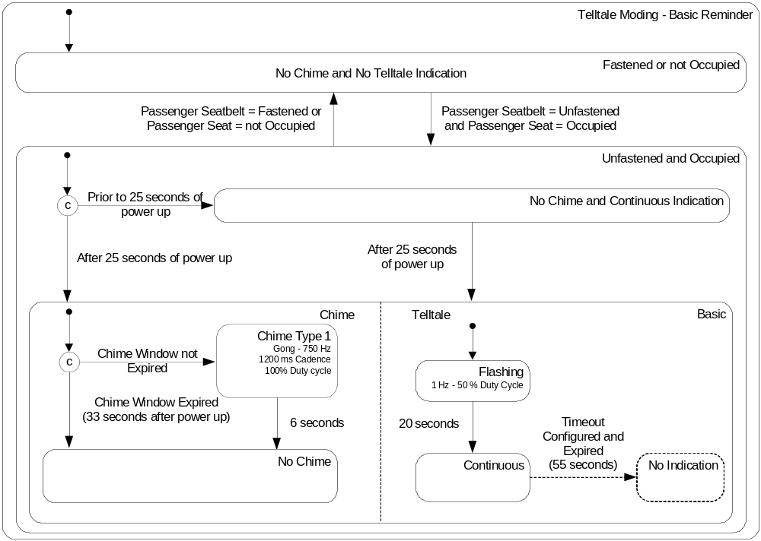
Figure 32 - Passenger Seatbelt Reminder - Telltale Mode - Basic Reminder

a. If the configuration option for Telltale mode is Basic Reminder Operation then the ACU shall meet the requirements shown in Figure 32 with detailed requirements specified herein.
b. When the passenger seatbelt is unfastened and passenger seatbelt reminder occupancy status is occupied then
1. If the feature is enabled for less than 25.0 ± 0.1 seconds then
i. The ACU shall not turn the chime “on”.
ii. The ACU shall turn the telltale continuous “on”.
2. If the feature is enabled for greater than 25.0 ± 0.1 seconds then
i. If the feature is enabled for less than 33.0 ± 0.1 seconds and the ACU is not in assembly plant mode and the ACU is configured with Chime Usage for Extended Reminder then the ACU shall turn the chime “on” (Gong - 750 Hz, 1200 ms cadences with 100% duty cycle) for 6.0 ± 0.1 seconds otherwise the ACU shall not turn the chime “on”.
ii. The ACU shall flash the telltale “on” and “off” at a 1 Hz rate with 50% duty cycle for 20.0 ± 0.1 seconds and then
a) If the ACU is not configured with continuous reminder timeout option then the ACU shall turn the telltale continuous “on”.
b) If the ACU is configured with continuous reminder timeout option then the ACU shall turn the telltale “on” for 55.0 ± 0.1 seconds and then turn the telltale “off”.

3.4.1.2.2 Enhanced Reminder Operation
This section defines the enhanced reminder operation which provides multiple reminder sequence for unfastened passenger seatbelt condition. This operation uses vehicle speed to initiate enhanced reminder and provides additional audible/visible warnings.

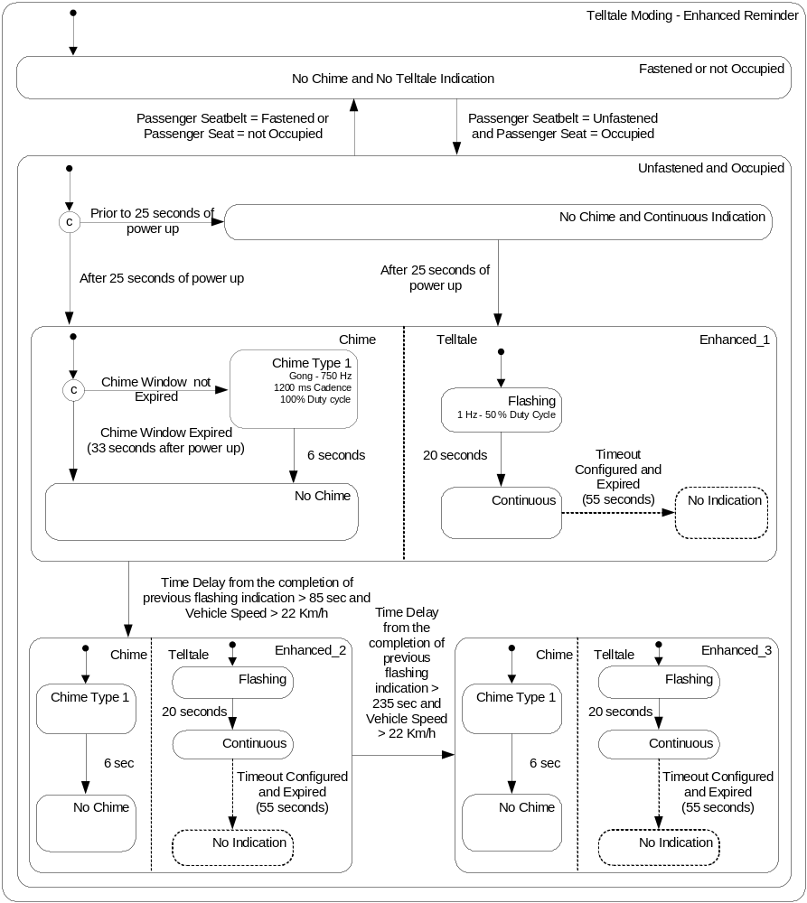
Figure 33 - Passenger Seatbelt Reminder - Telltale Moding - Enhanced Reminder

a. If the configuration option for Telltale mode is Enhanced Reminder Operation then the ACU shall meet the requirements shown in Figure 33 with detailed requirements specified herein.
b. When the passenger seatbelt status is unfastened and the passenger seatbelt reminder occupancy status is occupied then
1. If the feature is enabled for less than 25.0 ± 0.1 seconds then
i. The ACU shall not turn the chime “on”.
ii. The ACU shall turn the telltale continuous “on”.
2. If the feature is enabled for greater than 25.0 ± 0.1 seconds then
i. If the feature is enabled for less than 33.0 ± 0.1 seconds and the ACU is not in assembly plant mode and the ACU is configured with chime usage for extended reminder then the ACU shall turn the chime “on” (Gong - 750 Hz, 1200 ms cadences with 100% duty cycle) for 6.0 ± 0.1 seconds otherwise the ACU shall not turn the chime “on”.
ii. The ACU shall flash the telltale “on” and “off” at a 1 Hz rate with 50% duty cycle for 20.0 ± 0.1 seconds and then
a) If the ACU is not configured with continuous reminder timeout option then the ACU shall turn the telltale continuous “on”.
b) If the ACU is configured with continuous reminder timeout option then the ACU shall turn the telltale “on” for 55.0 ± 0.1 seconds and then turn the telltale “off”.
3. When 85.0 ± 0.1 seconds expires since the completion of the previous flashing indication and the Vehicle Speed exceeds 22 km/h then
i. If the ACU is not in assembly plant mode and the ACU is configured with chime usage for extended reminder then the ACU shall turn the chime “on” (Gong - 750 Hz, 1200 ms cadences with 100% duty cycle) for 6.0 ± 0.1 seconds other wise the ACU shall not turn the chime “on”.
ii. The ACU shall flash the telltale “on” and “off” at a 1 Hz rate with 50% duty cycle for 20.0 ± 0.1 seconds and then
a) If the ACU is not configured with continuous reminder timeout option then the ACU shall turn the telltale continuous “on”.
b) If the ACU is configured with continuous reminder timeout option then the ACU shall turn the telltale “on” for 55.0 ± 0.1 seconds and then turn the telltale “off”.
4. When 235.0 ± 0.1 seconds expires since the completion of the previous flashing indication and the Vehicle Speed exceeds 22 km/h then
i. If the ACU is not in assembly plant mode and the ACU is configured with chime usage for extended reminder then the ACU shall turn the chime “on” (Gong - 750 Hz, 1200 ms cadences with 100% duty cycle) for 6.0 ± 0.1 seconds otherwise the ACU shall not turn the chime “on”.
ii. The ACU shall flash the telltale “on” and “off” at a 1 Hz rate with 50% duty cycle for 20.0 ± 0.1 seconds and then
a) If the ACU is not configured with continuous reminder timeout option then the ACU shall turn the telltale continuous “on”.

b) If the ACU is configured with continuous reminder timeout option then the ACU shall turn the telltale “on” for 55.0 ± 0.1 seconds and then turn the telltale “off”.

3.4.1.2.3 Euro Reminder Operation
This section defines the euro reminder operation which provides multiple reminder sequence for unfastened passenger seatbelt condition. This operation uses engine run active, vehicle speed, distance traveled, and passenger door status to initiate reminder and provides additional audible/visual warnings. It is designed to meet EuroNCAP requirements.
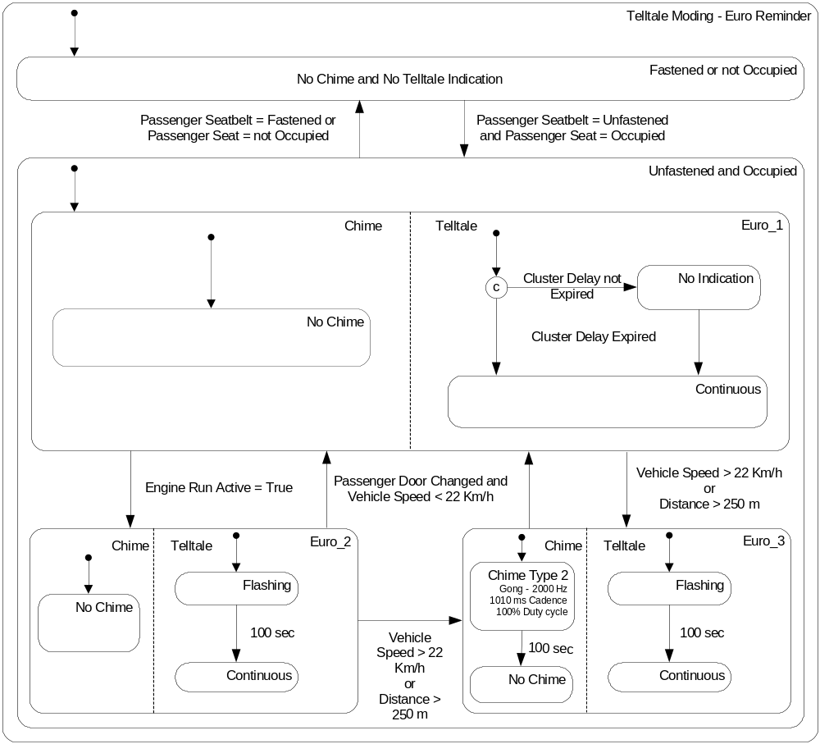
Figure 34 - Passenger Seatbelt Reminder - Euro Reminder
a. If the configuration option for Telltale moding is Euro Reminder Operation then the ACU shall meet the requirements shown in Figure 34 with detailed requirements specified herein.
b. During the first 4.0 ± 0.1 seconds (calibrateable) of enabling this feature, the ACU shall not command telltale or chime.
c. When the passenger seatbelt is unfastened and the passenger seatbelt reminder occupancy status is occupied after the first 4.0 ± 0.1 seconds (calibrateable) of enabling this feature then
1. The distance traveled with the passenger unfastened condition shall be initially set to zero.
2. The ACU shall turn the telltale continuous “on”.
3. When the Engine Run Active becomes True then
i. The ACU shall flash the telltale “on” and “off” at a 1 Hz rate with 50% duty cycle for 100.0 ± 0.1 seconds and then turn the telltale continuous “on”.
4. When the Vehicle Speed exceeds 22 km/h or distance traveled with the passenger unfastened condition exceeds 250 m then
i. The ACU shall flash the telltale “on” and “off” at a 1 Hz rate with 50% duty cycle for 100.0 ± 0.1 seconds and then turn the telltale continuous “on”.
ii. If the ACU is not in assembly plant mode and the ACU is configured with chime usage for extended reminder then the ACU shall turn the chime “on” (Gong - 2 KHz, 1010 ms cadences with 100% duty cycle) for 100.0 ± 0.1 seconds other wise the ACU shall not turn the chime “on”.
5. If the Passenger Door Status changes and Vehicle Speed is less than 22 km/h then
i. The distance traveled with the passenger unfastened condition shall b reset to zero.
ii. If the chime is active then the chime shall be turn “off”.
iii. The ACU shall turn the telltale continuous “on”.
iv. The ACU shall re-initiate the passenger seatbelt unfastened reminder sequence depending on engine run active, vehicle speed and distance traveled conditions as specified above in c.

3.4.1.2.5 Enhanced DIC Moding
In an optional Enhanced DIC moding, a text message (“Buckle Passenger”) is displayed in addition to the use of telltale for unfastened passenger seatbelt condition.
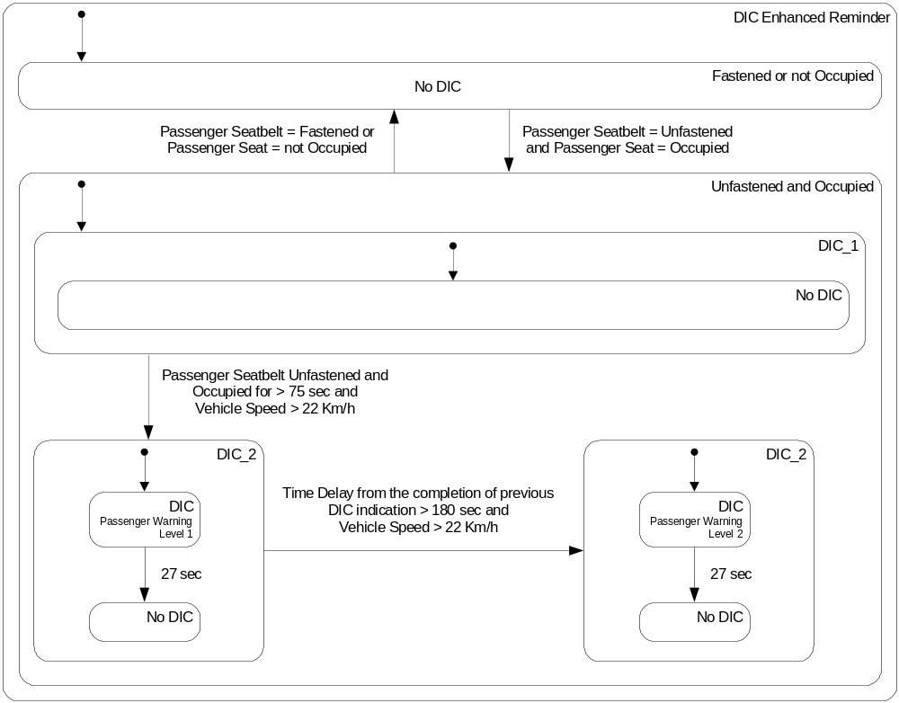
Figure 36 - Passenger Seatbelt Reminder - Enhanced DIC Moding
a. The ACU shall allow Enhanced DIC Moding to be available as a configurable option.
b. The ACU shall use the following CAN signal to control Enhanced DIC moding.

c. The ACU shall not activate Enhanced DIC moding if the ACU is in the assembly plant mode.
d. If the ACU is configured for Enhanced DIC moding and the ACU is not in the assembly plant mode then the ACU shall meet the requirements shown in Figure 36 with detailed requirements specified herein.
e. The ACU shall turn the DIC Indication “off” when any of the following conditions is true.

1. The passenger seatbelt becomes fastened
2. The passenger seatbelt reminder occupancy status changes to “Empty”
3. The passenger seatbelt reminder occupancy status changes to “Unknown”
f. When the passenger remains unfastened and the passenger seatbelt reminder occupancy status remains occupied for 75.0 ± 0.1 seconds and the Vehicle Speed exceeds 22 km/h then
1. The ACU shall turn the DIC Indication “on” for 27.0 ± 0.1 seconds and then turn the DIC Indication “off”.
g. When 180.0 ± 0.1 seconds expires since the completion of the previous DIC indication and the Vehicle Speed exceeds 22 km/h then
1. The ACU shall turn the DIC Indication “on” for 27.0 ± 0.1 seconds and then turn the DIC Indication “off”.

3.4.1.3 Deactivation of Passenger Seatbelt Reminder Operation
a. The ACU shall allow a configuration option - Chime Usage for Extended Reminder, which will activate or deactivate the seatbelt reminder chime without affecting regulatory requirements for seatbelt reminder operations to be modified using diagnostic services.
ID : 426

3.4.2 Behavior Description
Not applicable

3.4.3 Operation Modes
Not applicable

3.4.4 Initialization
h. The ACU shall use the passenger seatbelt status as “fastened” and passenger occupancy status as “unknown” as a default during power up.
The ACU shall use the telltale “off” and chime “off” as s default during power up.

3.4.5 Self-diagnosis Aspects
Not applicable

3.4.6 Configuration
See 3.4.1.1 General section

3.4.7 Fault Handling and Reaction
Not applicable

6 DIC Manager

6.1 INTRODUCTION

6.1.1 Purpose
This document establishes the requirements for the software component DIC manager to be implemented as part of the project ACU.

6.1.2 Scope
The requirements described here are valid for the ACU. If generic requirements are used, they are linked to the generic requirement specification.

6.1.3 Reference Documents

6.2 DEVELOPMENT CONTEXT

6.2.1 Component Borderlines
The DIC manager is responsible to abstract the DIC indications from the CAN messages needed to perform the indications.

6.2.2 Development and Design Constraints
The runtime of the DIC manager functions basically does not need to be restricted, because these functions are executed within an OSEK task, but this runtime has to be balanced against the runtime of other tasks with regard to the overall available runtime.

6.2.3 Concept
The DIC manager is only a collection of functions that abstracts DIC indications from CAN messages. There is not a cyclic handler function neither an init function.

6.3 INTERFACES

6.3.1 Inputs Processed by the Component
There is not an input processed by DIC manager

6.3.2 Outputs Generated by the Component
CAN messages to command DIC indications for:
- Airbag Warning Lamp
- Driver seat belt reminder
- Passenger seat belt reminder

6.4 FUNCTIONAL SPECIFICATION

6.4.1 Fault Indication DIC Moding
In an optional Fault Indication DIC moding, a text message (“Service Air Bag”) is displayed in addition to the use of telltale if one or more active faults requiring DIC message are present.
a. The ACU shall allow Fault Indication DIC Moding feature to be available as a configuration option.
b. The ACU shall use the following CAN signal to control Fault Indication DIC moding.

c. The ACU shall use the DIC indication “off” as a default during power up.
d. The ACU shall enable DIC moding when all of the following conditions are met.
1. ACU Power Mode is RUN and
2. ACU is not in assembly plant mode and
3. ACU is configured to use DIC moding for indicating faults
e. The ACU shall disable DIC moding if any condition to enable DIC moding is not met.
f. The ACU shall turn the DIC indication “off” when DIC moding is disabled.
g. If no faults are active or the ACU qualified fault(s) is active not requiring DIC indication then the ACU shall turn the DIC indication “off”.
h. If the ACU qualified fault(s) is active requiring DIC indication then the ACU shall command to turn the DIC indication “on” (which will display text message “Service Air Bag” in the DIC) for the duration of the active fault requiring DIC indication.

7 Chime Manager

7.1 INTRODUCTION

7.1.1 Purpose
This document establishes the requirements for the software component Chime manager to be implemented as part of the project ACU AEP

7.1.2 Scope
The requirements described here are valid for the ACU AEP If generic requirements are used, they are linked to the generic requirement specification.

7.1.3 Reference Documents

7.2 DEVELOPMENT CONTEXT

7.2.1 Component Borderlines
The Chime Manager is responsible for command the chime using CAN messages. It also keeps track of the Chime Active signal, to re-send the chime request if necessary

7.2.2 Development and Design Constraints
The runtime of the Chime manager functions basically does not need to be restricted, but this runtime has to be balanced against the runtime of other tasks with regard to the overall available runtime.

7.2.3 Concept
The Chime manager is realized as an state machine.

7.3 INTERFACES

7.3.1 Inputs Processed by the Component
- The Chime manager shall process all the requests from Driver, Passenger and Rear Seat Belt Reminders submodules with the data of which module put the request, and the time that the chime must be active.
- The chime active message available as a CAN message

7.3.2 Outputs Generated by the Component
The CAN messages needed to configure the following chime parameters:
- Sound tone
- Sound cadence period
- Sound duty cycle
- Chime message priority
- Number of repetitions
- Sound location

7.4 FUNCTIONAL SPECIFICATION

7.4.1 Behavior Description

7.4.1.1 Driver
The ACU shall use the following CAN message consisting of Sound Tone, Sound Cadence Period, Number of Repetitions, Sound Duty Cycle, Sound Location, and Sound Priority signals to control driver seatbelt reminder chime moding.


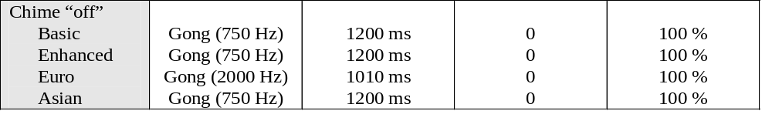
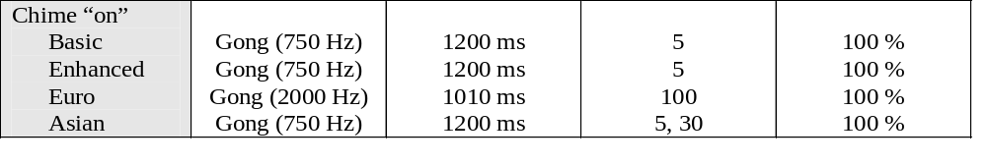
As ACU uses only a single chime command to control all seatbelt reminder moding, it shall act as a chime manager as specified below.
1. If a ACU driver seatbelt reminder chime is active and the driver seatbelt is fastened during this chime period, then the ACU shall command the chime “off” unless it is required by front passenger or rear passenger seatbelt reminder feature.
2. If the ACU activated driver seatbelt reminder chime has been active for the desired chime period without a change in the driver seatbelt status, then the ACU shall not command the chime “off”. (The chime will terminate normally due to reaching the desired number of repetitions requested on the chime initiation.)
2. If the ACU activated driver seatbelt reminder chime has been active for the desired chime period without a change in the driver seatbelt status, then the ACU shall command the chime “off” unless it is required by front passenger or rear passenger seatbelt reminder feature.
3. The ACU shall meet the following requirements for re-transmitting the chime command.
i. The ACU shall re-transmit the chime command message encoded to turn “on” the chime, if the response, Chime Active confirmation message, is not received with its value set to “True” within 150 ms of completing the transmission of the chime command message.
ii. The ACU shall re-transmit the chime command message a maximum of seven times if the response as specified above is not met.
4. The ACU shall not command the chime for driver seatbelt reminder moding while the ACU is in assembly plant mode.
If the driver seatbelt status changes to fastened then the ACU shall turn the chime “off”, per requirements specified above for chime manager and the telltale “off”.
If the driver seatbelt status is unfastened then the ACU shall meet the requirements specified in Basic Reminder Operation or Enhanced Reminder Operation or Euro Reminder Operation depending on configurable option for telltale moding.

7.4.1.2 Passenger
d. The ACU shall use the following CAN message consisting of Sound Tone, Sound Cadence Period, Number of Repetitions, Sound Duty Cycle, Sound Location, and Sound Priority signals to control passenger seatbelt reminder chime moding.

f. As ACU uses only a single chime command to control all seatbelt reminder moding, it shall act as a chime manager as specified below.
1. If a ACU passenger seatbelt reminder chime is active and the passenger seatbelt is fastened or passenger seat becomes not occupied (suggested either by CAN message or Seatbelt Reminder Sensor) during this chime period, then the ACU shall command the chime “off” unless it is required by driver or rear passenger seatbelt reminder feature.
2. If the ACU activated passenger seatbelt reminder chime has been active for the desired chime period without a change in the passenger seatbelt or seatbelt reminder occupancy status then the ACU shall not command the chime “off”.
2. If the ACU activated passenger seatbelt reminder chime has been active for the desired chime period without a change in the passenger seatbelt or seatbelt reminder occupancy status then the ACU shall command the chime “off” unless it is required by driver or rear passenger seatbelt reminder feature.
3. The ACU shall meet re-transmitting the chime command requirements as specified in Section 3.6.3.14.2.d.3. for driver seatbelt telltale moding.
4. The ACU shall not command the chime for passenger seatbelt reminder moding while the ACU is in assembly plant mode.
g. The ACU shall turn the chime “off” as per requirements specified above for chime manager and telltale “off” when any of the following conditions is true.
1. The passenger seatbelt becomes fastened
2. The passenger seatbelt reminder occupancy status changes to “Empty”
3. The passenger seatbelt reminder occupancy status changes to “Unknown”
h. The ACU shall meet the requirements specified in Basic Reminder Operation or Enhanced Reminder Operation or Euro Reminder Operation depending on configurable option for telltale moding when all of the following conditions are true.
1. The passenger seatbelt status is unfastened and
2. The passenger seatbelt reminder occupancy status is occupied (using either CAN message or Seatbelt Reminder Sensor).

8 Passenger Occupancy Manager

8.1 INTRODUCTION

8.1.1 Purpose
This document establishes the requirements for the software component Chime manager to be implemented as part of the project ACU AEP

8.1.2 Scope
The requirements described here are valid for the ACU AEP.

8.2 DEVELOPMENT CONTEXT

8.2.1 Component Borderlines
The Module will be the responsible to read the Driver and Passenger seat buckle sensors and Passenger Seat Sensor and provide the status to the related Modules.
Read the corresponding sensors voltage values, perform the filtering and provide the status.

8.2.2 Development and Design Constraints
The runtime of the passenger occupancy manager functions basically does not need to be restricted, but this runtime has to be balanced against the runtime of other tasks with regard to the overall available runtime.

8.2.3 Concept
The passenger occupancy manager is realized as an state machine.

8.3.2 Outputs Generated by the Component
Driver Seat Belt Status, Passenger Seat Belt status and Passenger Seat Status

8.3 INTERFACES

8.3.1 Inputs Processed by the Component
The module shall read the sensors as a voltage input.

8.4 FUNCTIONAL SPECIFICATION

8.4.1 Behavior Description

8.4.1.1 Driver and Passenger Seat Belt Sensor.

If the system reads a voltage greater than 20 Volts the state shall be considered as a faulty state.
A system voltage reading between 12v and 20v volts shall be considered as Buckle state.
A system voltage reading greater than 10 and less than 12 volts shall be considered as an undetermined state.
A system voltage reading between 2 and 10 volts shall be considered as an Unbuckle state.
A system voltage reading between 0 and less than 2volts shall be considered as faulty state.
The system shall sample every 200 ms +/- 10 ms the input voltage.
The system shall assert a new status when 5 consecutive readings in the same state are detected.

8.4.1.2 Passenger Seat Sensor
If the system reads a voltage greater than 20 Volts the state shall be considered as a faulty state.
A system voltage reading between 12v and 20v volts shall be considered as Unoccupied state.
A system voltage reading greater than 10 and less than 12 volts shall be considered as an undetermined state.
A system voltage reading between 2 and 10 volts shall be considered as an Occupied state.
A system voltage reading between 0 and less than 2volts shall be considered as faulty state.
The system shall sample every 500 ms +/- 25 ms the input voltage.
The system shall assert a new status when 6 consecutive readings in the same state are detected.

